khaneilcampbell.com Portfolio Site
Technical Deep Dive · web-01
Project ID | Scope of this document | Last verified
web-01 | How the site is built, secured, deployed and checked | 2026-10-26
Labels. [Verified] read in the repository · [Inferred] my reasoning · [Recommended] a suggestion.

1. System Architecture
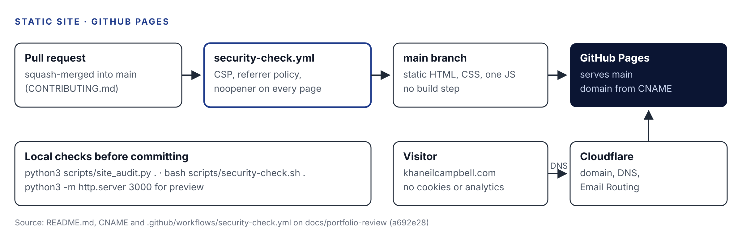
Hosting and change flow
[Verified] 14 static HTML pages at the repository root, one stylesheet, one script, fonts and images under assets/ and images/. GitHub Pages serves main; Cloudflare handles the domain and email routing.

2. Components
Component | Path | Responsibility
Pages | *.html | Home, About, Work, two case studies, labs index and details, Contact, four credential pages, Privacy, 404
Design system | assets/site.css | Tokens, layout, the .ad architecture-diagram component
Enhancement | assets/site.js | Reveals, mobile menu, magnetic buttons, diagram inspector with keyboard support
Fonts | assets/fonts/ | Instrument Sans and Serif, Latin subset, SIL OFL 1.1
Crawl | robots.txt, sitemap.xml | Search engine directives
Audits | scripts/ | site_audit.py, site_inventory.py, security-check.sh
Planning | docs/VISION.md, docs/PORTFOLIO-PLAN.md | Positioning, verified content, decisions

3. Integrations
[Verified] None at runtime. The CSP sets connect-src 'none' and form-action 'none', so the site cannot call any API or submit a form.

4. Authentication
[Verified] None. Contact is through email links.

5. Data Flows
[Verified] Browser requests static files from GitHub Pages. No data leaves the browser.

6. Structures
[Verified] Every page carries: a CSP meta tag, a referrer policy, canonical and Open Graph tags, JSON-LD (WebPage linked to a site-wide Person, plus BreadcrumbList), and rel="noopener noreferrer" on any target="_blank" link.
Content Security Policy on index.html:
default-src 'none'; script-src 'self'; style-src 'self'; font-src 'self';
img-src 'self' data:; manifest-src 'self'; connect-src 'none';
base-uri 'self'; form-action 'none';

7. Error Handling
[Verified] A custom 404.html. Every feature degrades to plain HTML when JavaScript is off or prefers-reduced-motion is set.

8. Monitoring
[Verified] None beyond CI. No analytics by design.

9. Security Considerations
Control | State | Label
Strict CSP, no inline scripts or styles | Implemented | Verified
No third-party origins | Implemented | Verified
Referrer policy on every page | Implemented and checked in CI | Verified
Real HTTP security headers | Not possible on GitHub Pages; _headers is for a future host | Verified
Public résumé without phone number | Implemented | Verified
CI action pinned by tag (actions/checkout@v4), not by SHA | Open | Verified

10. Deployment Architecture
[Verified] Squash-merged pull requests to main; GitHub Pages publishes automatically; CNAME sets the domain. Assets are cached for ten minutes, which is why URLs carry a content hash.

11. Testing Methodology
[Verified] CI: CSP, referrer policy and noopener checks on every HTML file. Locally: site_audit.py (credential-shaped strings, missing alt, insecure links, broken local links) and security-check.sh. I ran both on docs/portfolio-review on 2026-10-26: 14 pages, 0 failures, 0 warnings; 133 checks passed.

12. Troubleshooting Procedures
Symptom | Cause | Fix
New layout with old styling | Hash in CSS URL not updated | Recompute the hash and update the link
Style silently ignored | Inline style blocked by CSP | Move it to a class in site.css
CI fails “Missing CSP meta tag” | New page without the head block | Copy the head from an existing page
Font fails to load | Font not in assets/fonts/ | Self-host it; CSP blocks other origins

13. Performance Considerations
[Verified] Inline SVG covers and self-hosted subset fonts keep requests low; two upright faces are preloaded.

14. Future Engineering Improvements
[Recommended] Run site_audit.py in CI; pin actions by SHA; move to a host that sends real headers (Cloudflare Pages, decision D4) if header-only policies matter; add a writing section.

